

Vietnamese Study System for Japanese

INSTALLATION GUIDE DOCUMENT

Project Code: Veazy

Document Code: Veazy_Installation Guide_v1.1_EN

**Ha Noi, 10/08/2016**

Record of change

*A - Added M - Modified D - Deleted

|  |  |  |  |  |
| --- | --- | --- | --- | --- |
| Effective Date | Changed Items | A* M, D | Change Description | New Version |
| 10/08/2016 |  | A | Add new | v1.0 |
| 16/08/2016 |  | M |  | v1.1 |
|  |  |  |  |  |
|  |  |  |  |  |
|  |  |  |  |  |
|  |  |  |  |  |
|  |  |  |  |  |
|  |  |  |  |  |
|  |  |  |  |  |
|  |  |  |  |  |
|  |  |  |  |  |
|  |  |  |  |  |
|  |  |  |  |  |
|  |  |  |  |  |
|  |  |  |  |  |
|  |  |  |  |  |
|  |  |  |  |  |
|  |  |  |  |  |
|  |  |  |  |  |
|  |  |  |  |  |
|  |  |  |  |  |

SIGNATURE PAGE

ORIGINATOR: Đào Thanh Tùng 10/08/2016

Team member

REVIEWERS:

APPROVAL: Nguyễn Văn Sang

Supervisor

# Installation guide

## Introduction

This document contains guide-lines step by step to deploy Veazy website, and set up its own database.

## Pre-requisites

|  |  |  |  |
| --- | --- | --- | --- |
| No | Name | Version | Description |
| 1 | Windows | Windows XP or higher | Operating System |
| 2 | JDK | 8 | Java environment to run Tomcat |
| 3 | Tomcat | 7 | To deploy website |
| 4 | PostgreSQL | 9.3 or higher | To deploy database system |
| 5 | Browser | Firefox 20, Chrome 36 or higher | To browse the website |

Table 1: Environment requirement

## Application Installation

### Install web browser

* Chrome can be download from

<https://www.google.com/intl/vi/chrome/browser/desktop/index.html>

* Firefox can be download from

<https://www.mozilla.org/vi/firefox/new/>

### Install PostgreSQL 9.5.3

* Download and install PosgreSQL from:

<https://www.postgresql.org/download/>

* By default, the website server will listen on port 5432

### Create Database

* In Windows start bar find and open “pgAdmin III”

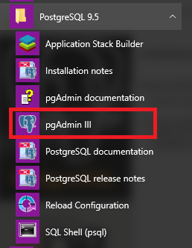

* Create new role

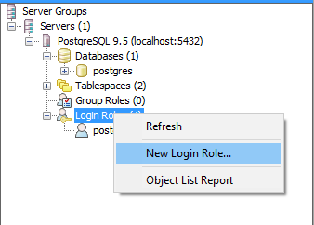

* Enter “veazy” to “Role name” box

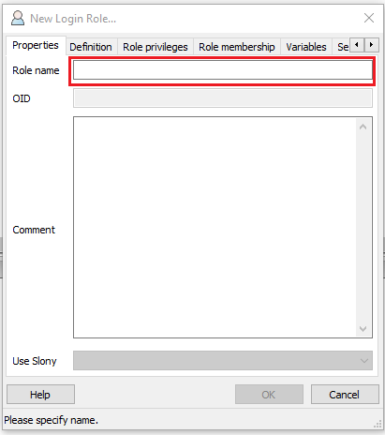

* Select “Definition” tab and enter “veazy” to password box

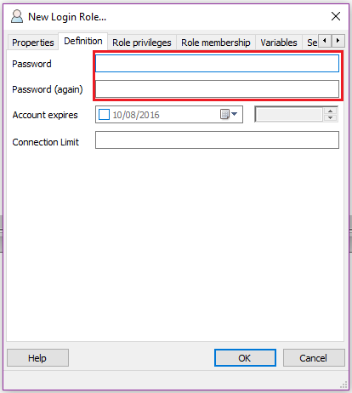

* Click “OK” button and see new role “veazy” has been created.

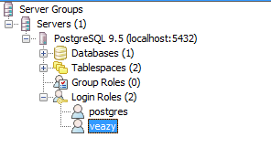

* Create new database

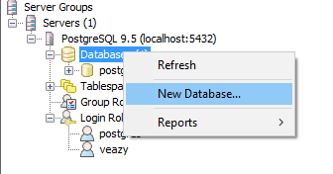

* Enter “veazy_system” into “Name” box and select “veazy” in “Owner” drop-down list

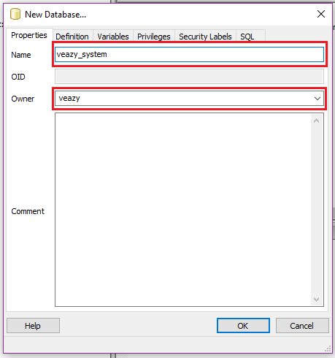

* Click “OK” button and see new database “veazy_system” has been created.

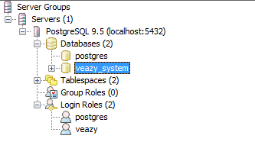

* Click  button on toolbar



* Click button on toolbar of new window



* Open “veazy.sql” file

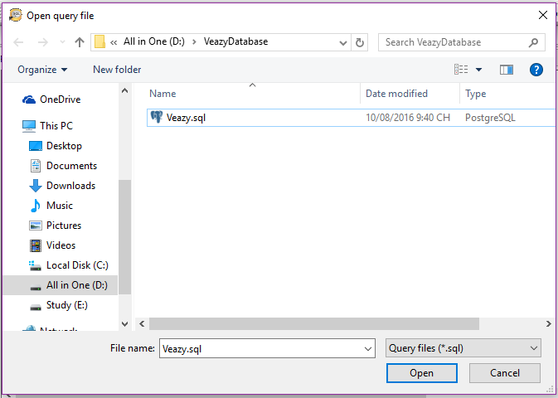

* Click  button on toolbar to run script



* Database was created with some table that contained data

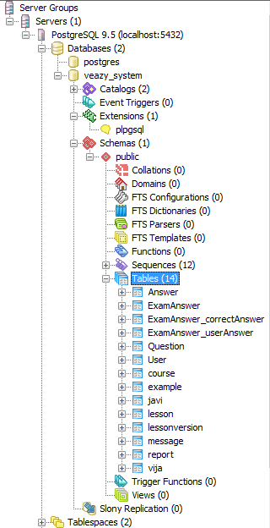

### Install JDK 8

* Go to link Install Java Platform (JDK) 8u101 (or later) from

<http://www.oracle.com/technetwork/java/javase/downloads/index.html>

* Set up JAVA_HOME follow guide

<https://docs.oracle.com/cd/E19182-01/820-7851/inst_cli_jdk_javahome_t/>

### Install Tomcat 7

* Download and install Tomcat 7 Core from

<https://tomcat.apache.org/download-70.cgi>

* Extract downloaded file and see extracted folder

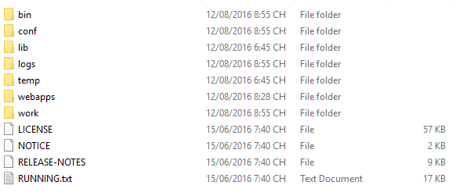

## Deploy server

* Copy file “Veazy.war” to “webapps” folder inner Tomcat folder

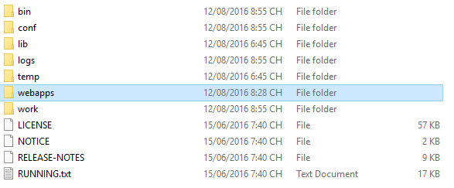

* Go to “bin” folder and run “startup.bat” file

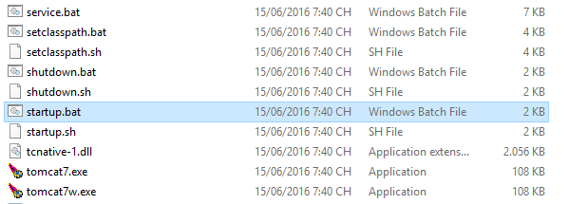

* Wait until the operation finish

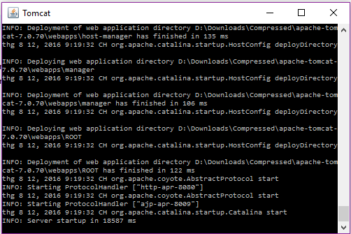

* Open browser and enter “localhost:8080/Veazy/” into address box and see deployed website
* Login with account “admin” and password “xxxxxxxx” to make sure the all installation is correct.

### Configure database connection

* Open file \webapps\Veazy\WEB-INF\appContext.xml by a text editor such as notepad

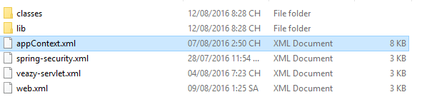

* You can configure database connection by change value of property in bean has id = “dataSource”

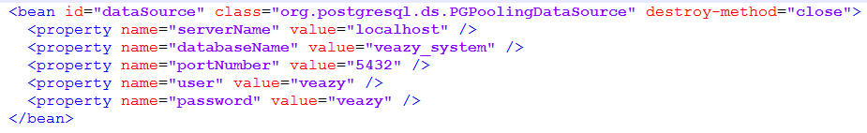

# Appendix